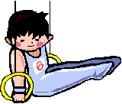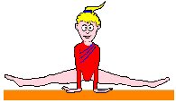
Let’s RUN, FLIP & TUMBLE @ Southern States Gymnastics!!
Birthday Parties available!
Saturday or Sunday’s available. Please check with the front office to reserve your party!!
Included is one hour of gymnastics fun for you and *seven of your closest friends with one of our certified Southern States Gymnastics coaches and use of our break room for whatever food and presents you provide.
Parties are limited to 2hour blocks. Need more time? See the front desk for extra fees.
Please have your guests wear leotards or gym clothes. NO jewelry or clothing with zippers, buttons or snaps is allowed on the gym floor.
All this amazing fun is only $150** for Southern States Gymnastics Members OR $175** for Non Members.
Book your party today!!
*extra friends can come for an additional $5 per friend**$25 non-refundable reservation fee required
Birthday Party Registration
Child’s Name:__________________________________________
Parent’s Name_________________________________________
Date of Party:____________Time:________PH #:_____________
# Extra friends:____Registration fee paid:______Check #:______
Member: yes or no Remainder due:___________Check #:______

